Research Document on Vhi Healthcare

Information to first fill out

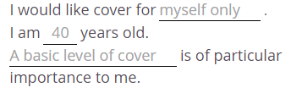

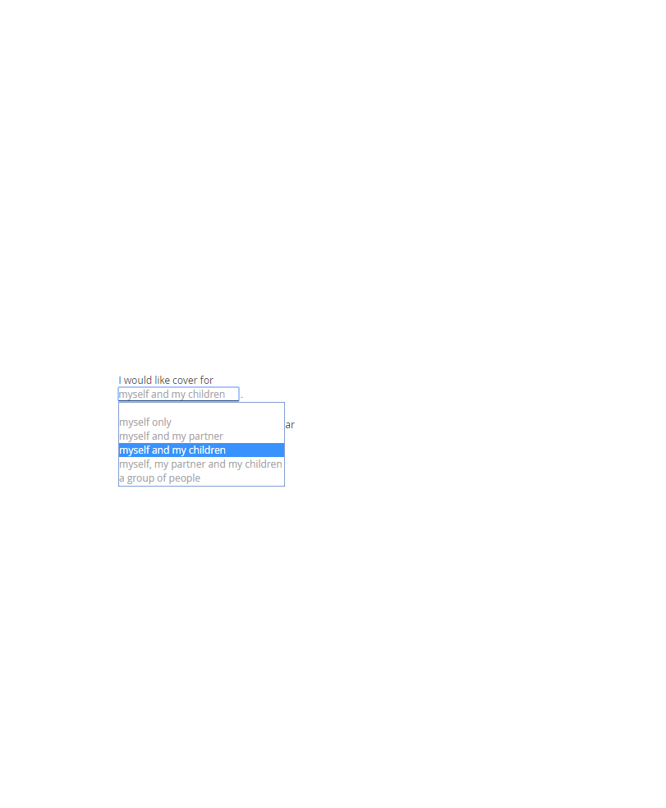Options for “I would like cover for”

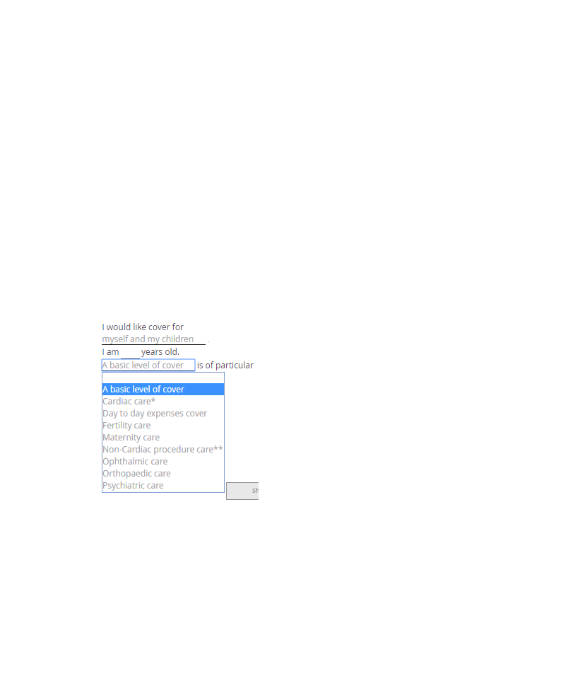Level of cover client wants

Important factors for the client signing up

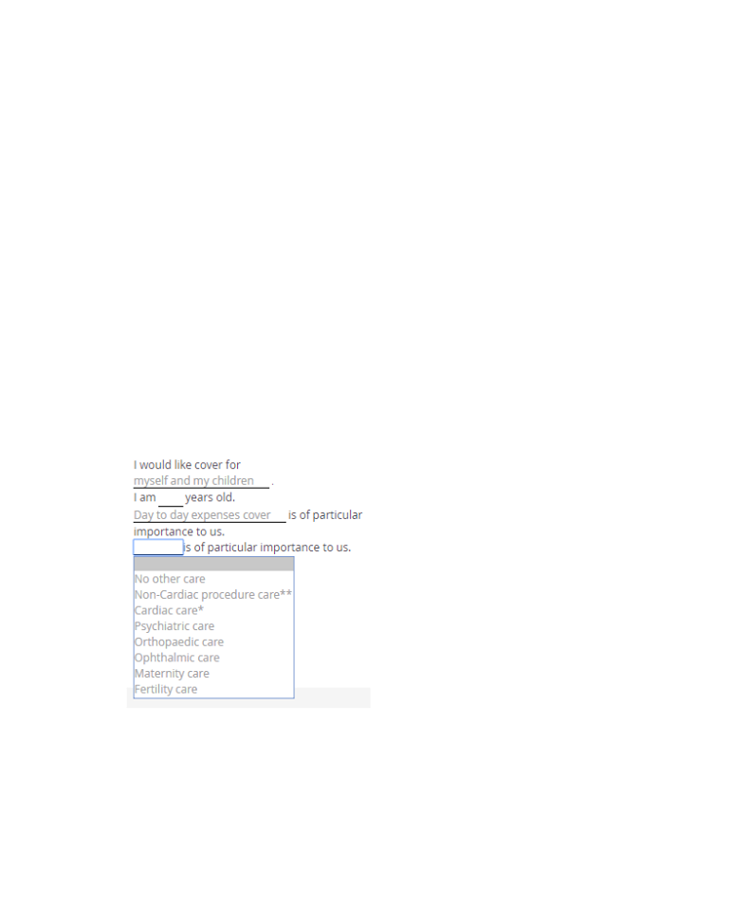

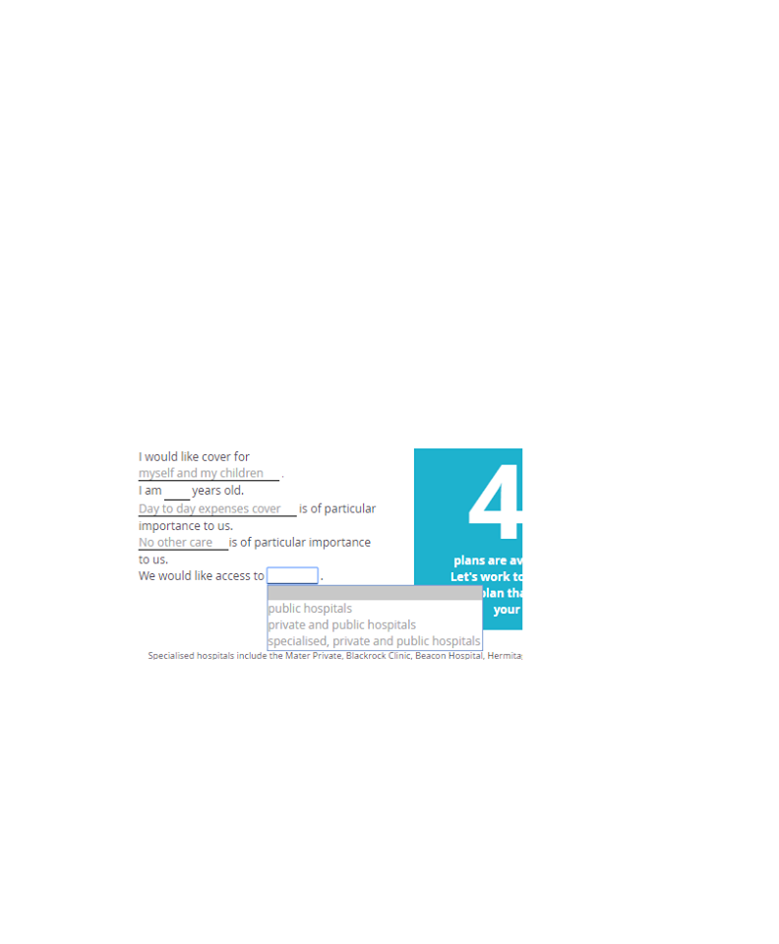Access to what kind of hospital

It also shows on the right of the form being filled out the number of plans that is available and this is updated as the form is being filled out.

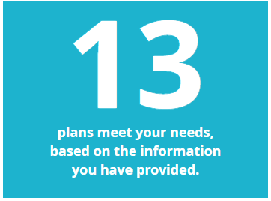

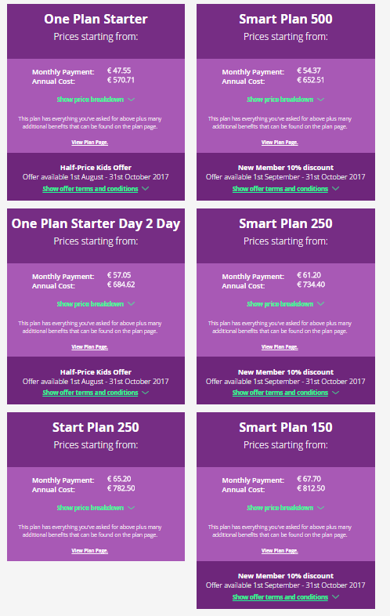Then it brings you to page to choose the plan you want on the same webpage

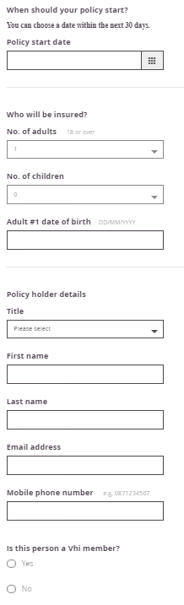Once the quote you select a pop up is then shown to fill out personal details and submit the form and wait for the VHI to get in contact. Once this is submitted VHI get in contact via email or phone with quote.